PENGAJUAN DANA CONTENT

1. IKLAN IG DETAILING
2. MONITOR MSI PRO MP 252 24.5 FHD IPS 100 H2 1MS BLACK

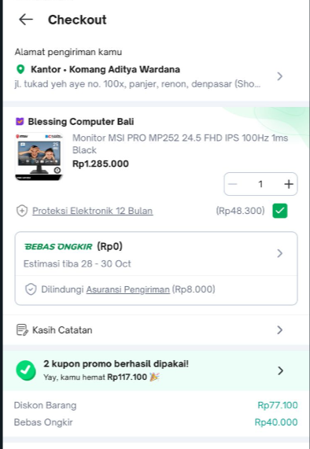

1. HARDDISK EXTERNAL 8+13 WD MYBOOK

